Ansys Ukpik-1 CubeSat Simulation

Created by: Nicholas Mitchell

Created for: Ukpik-1 CubeSat Project

# Section 1: Antenna Simulation

1. Tried to use Kelsey’s simplified model.

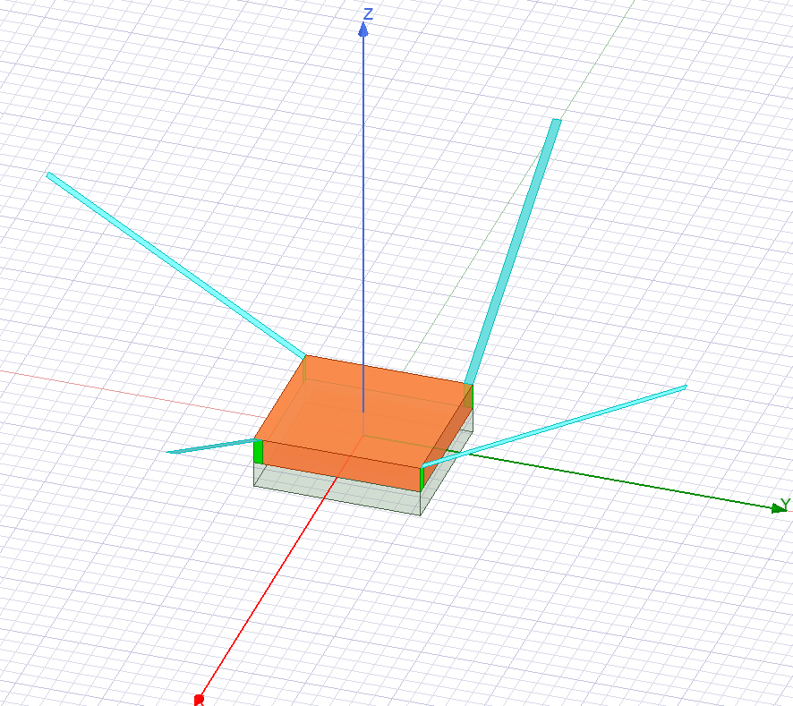

* Monopole were considered flat strips (and perfect conductors).
* 0,10,20,30,40,50,60,70,80,90 degree monopole simulations all worked and matched what she had in her capstone report
* Tried the intended 45 degree monopole simulation
* Ran into errors on compilation
  + The exciting strips (in green) were not connected to the monopoles (in light blue)
* Fixed the errors by:
  + Taking the 50 degree simulation, calculating the euler angles for each monopole and adjusting its position.
  + Compared the relative angle of the monopoles from my “new” model to kelsey’s old model. They look the same but this time my model has its lumped ports (green strips) actually attached to the monopoles in light blue)

Note for the following section I:

1. plot the antenna radiation pattern by itself then
2. plot the radiation pattern over the antenna to visualize it

* Tried to plot the results (via Kelsey’s method, used for all the other monopole angles 0-90): (note how bad the profile looks. This is not isotropic at all.)

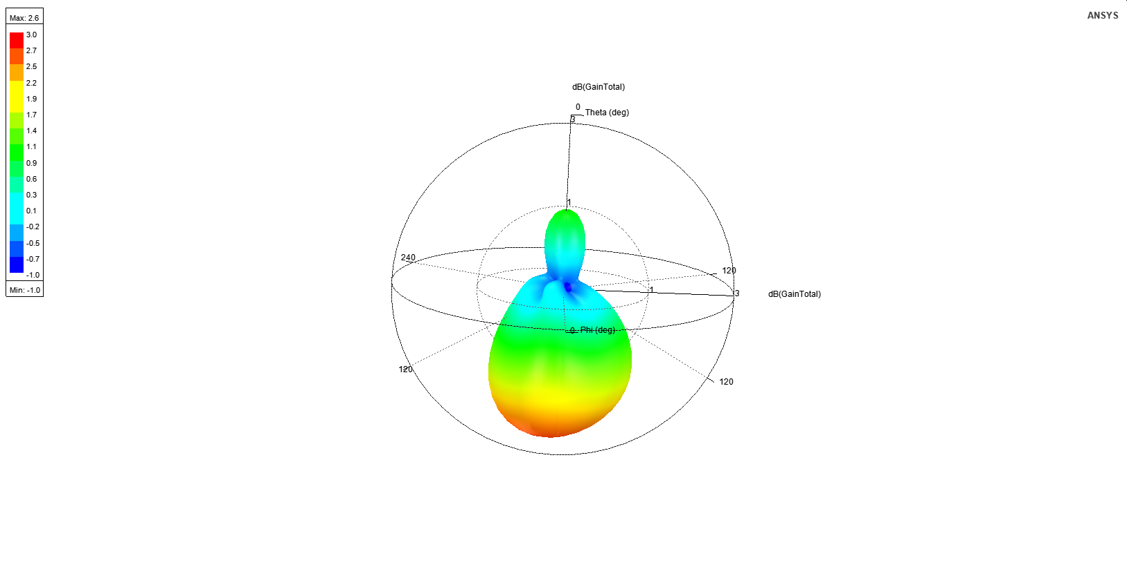

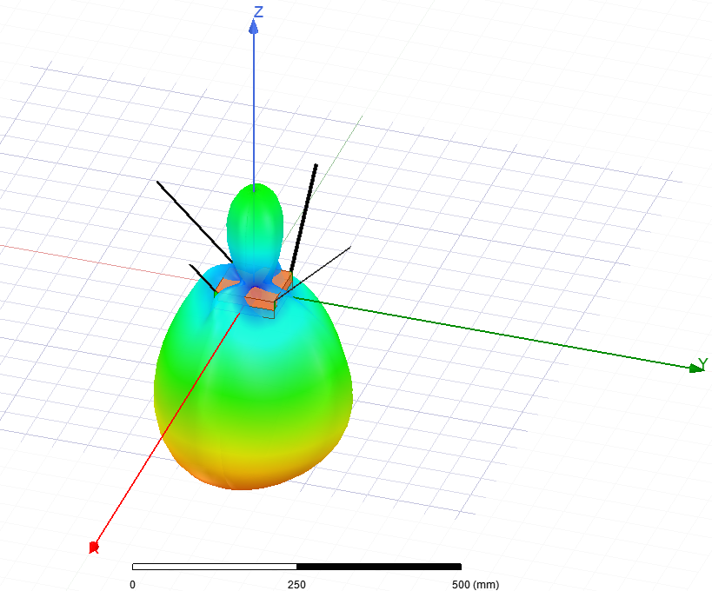

* Realizing that she had not considered the polarization of the resulting wave I plotted both the RHCP and the LHCP gains instead (since this did not match her final results at all.)
  + Note this is usually how a canted turnstile antenna works, it is not a linear antenna but a circular polarized system and it is important to plot.
  + This part was missing from her results and was likely not considered. Her 45 degree results look… a little suspect.
* LHCP:

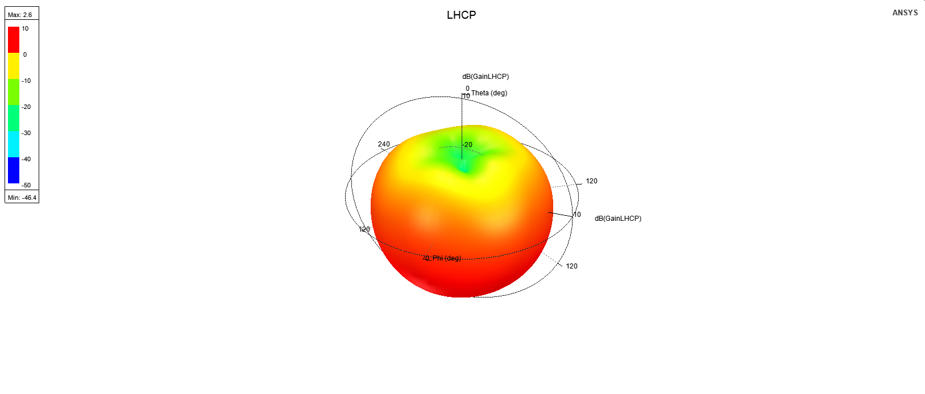

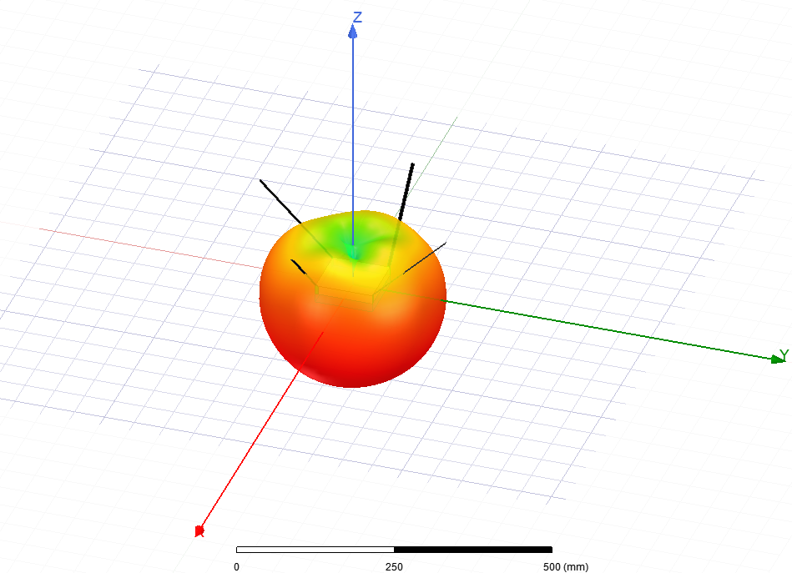

* RHCP:

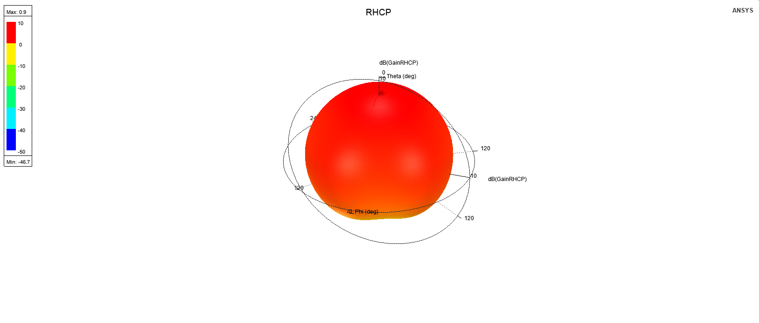

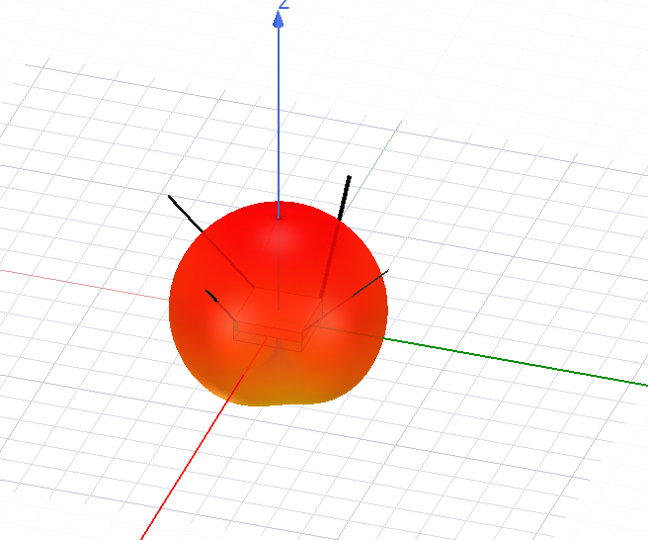

* Plotting both RHCP and LHCP to get a full view of the antenna propagation pattern: (not this can only be done overlayed on the antenna structure itself with no transparency)

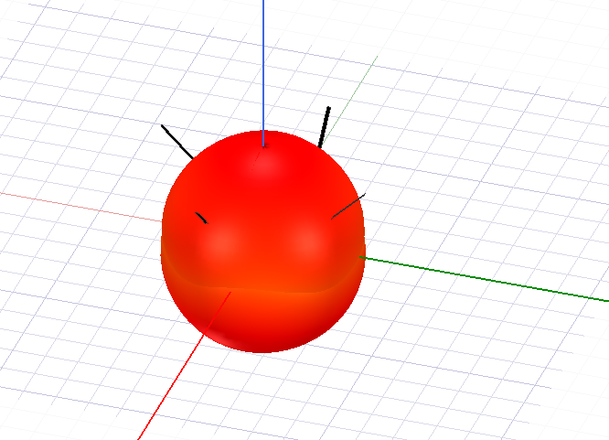

Note this is fairly uniform however there is a couple of issues with the design:

1. It uses infinitely thing strips as its monopoles
2. It has a copper ground plane not present in the desired antenna
3. It is missing the hole which is key to the actual functionality of the antenna

Conclusion: This model is not sufficient to move forward for simulating the radiation and propagation pattern of our cubesat when integrated with the structure.

1. Emailed GOMSpace in order to see if they had a model can use that would be more accurate. Their response is below:

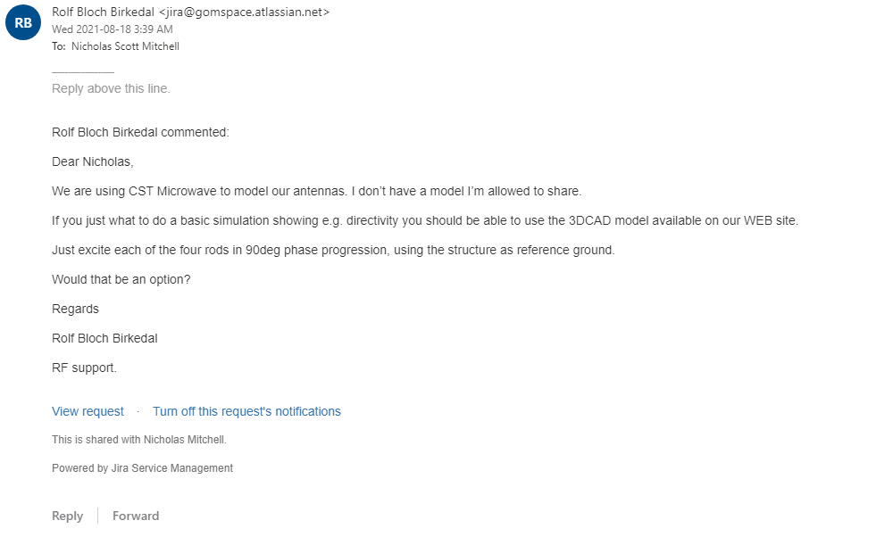

Conclusion: Need to

1. import the CAD model
2. simplify it to the bare minimum needed for the radiation and propagation model
3. define all the remaining components material properties
4. Assign lumped ports to each monopole
5. Assign phase angles for each source
6. Run the simulation
7. Importing the solidworks file

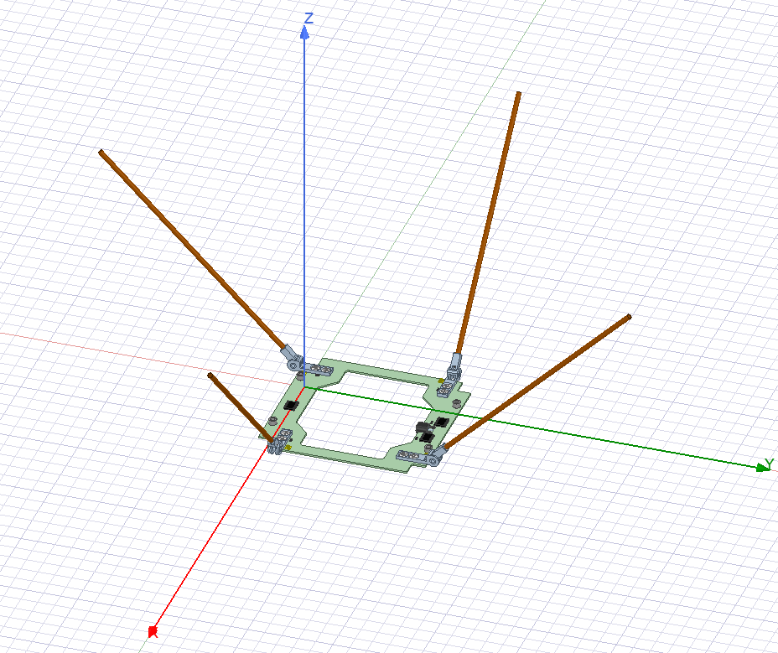

1. Remove all components which will not contribute to the overall radiation pattern

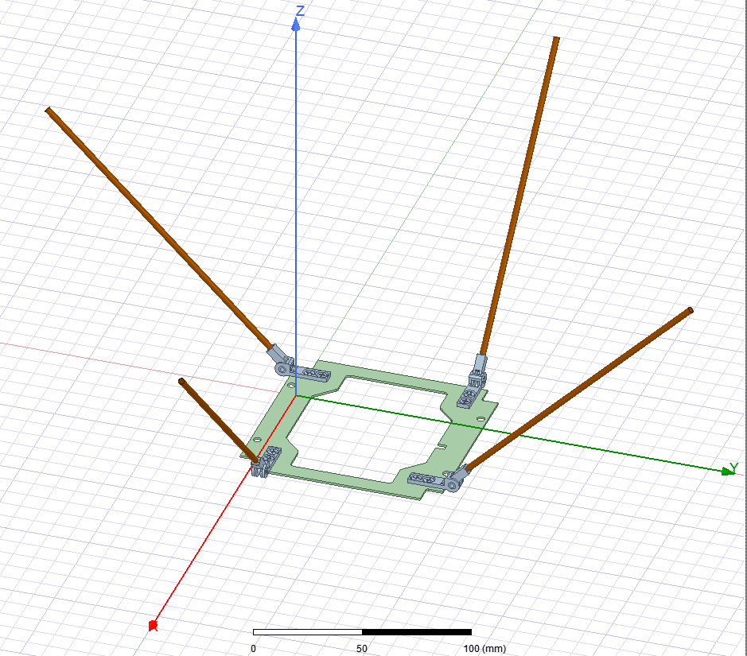

1. Upon running a simulation check it had issues with the hinges of the antenna. This caused an error since some components were overlapping. It was impossible to make them smaller as far as I know so I removed them as well.

* Note in the GOMSpace email they said just the monopoles and the base board need to be present, therefore I think it is a relatively safe assumption.

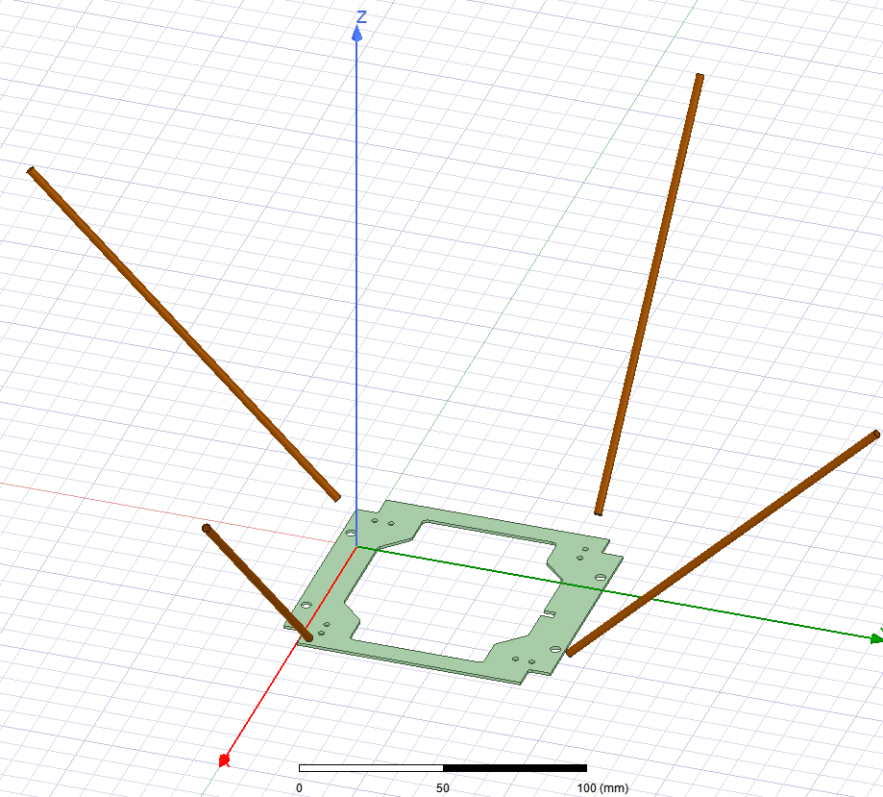

1. Assign material properties to antenna + pcb

Note: monopoles assumed to be perfect conductors, and pcb is noted as polyamide in the datasheet

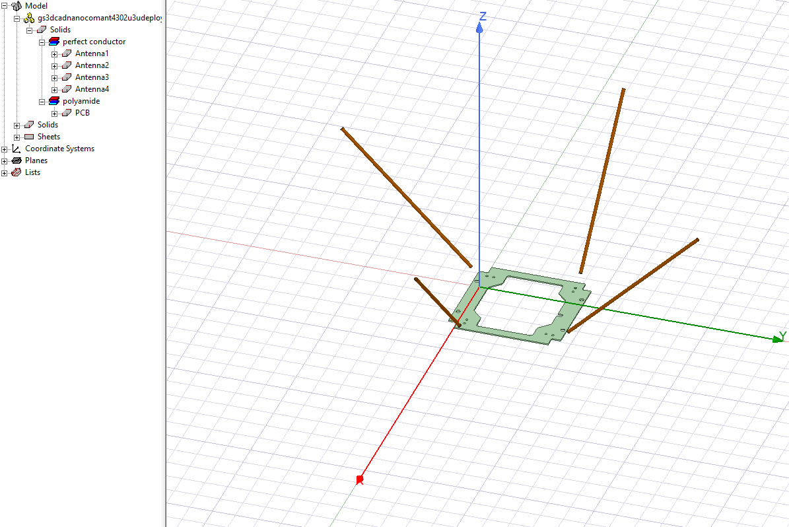

1. Assign coordinate system to each monopole and assign a lumped port to each monopole

Note the lumped port will deliver a Power (1W in our case from the endurosat board) at a certain phase to each of the ports.

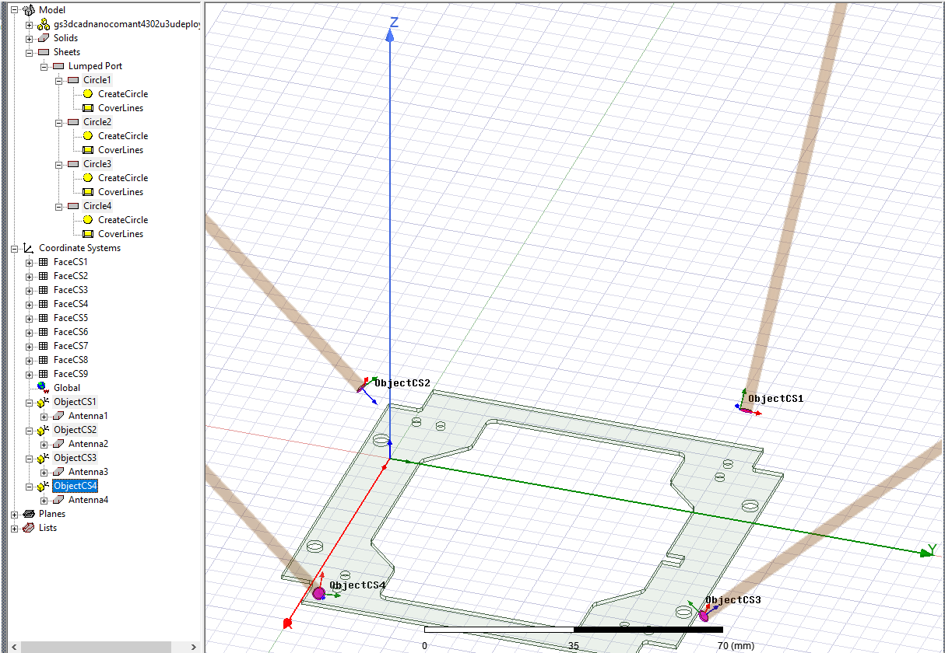

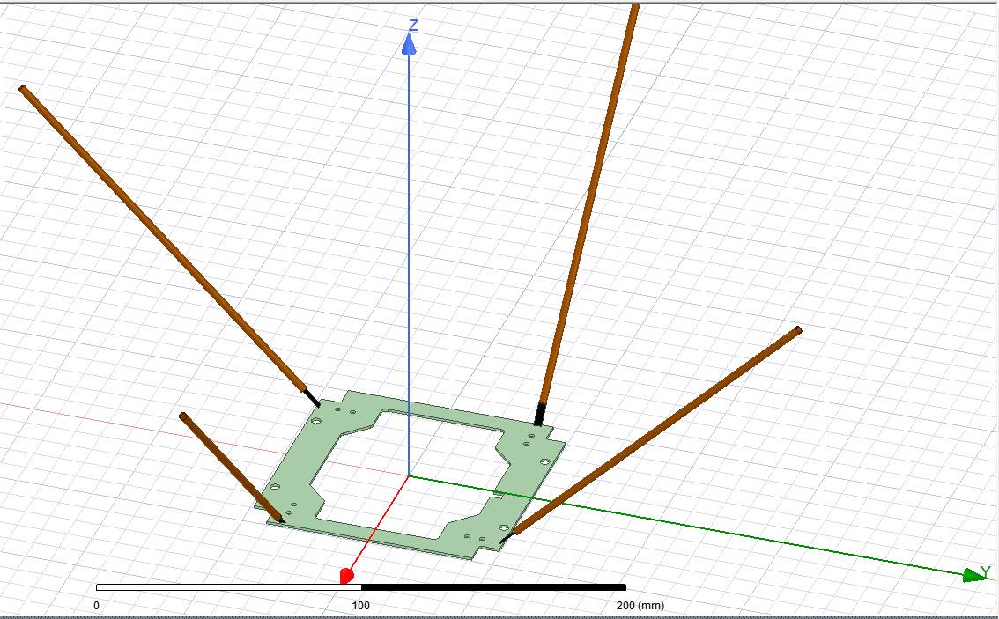

Also note that the integration line was always chosen to from the pcb (considered 0 V) to the antenna. Note the black objects are the gradient between the antenna and the pcb visualized.

1. Edit the sources going into each lumped port to have increasing phase and deliver 1 W

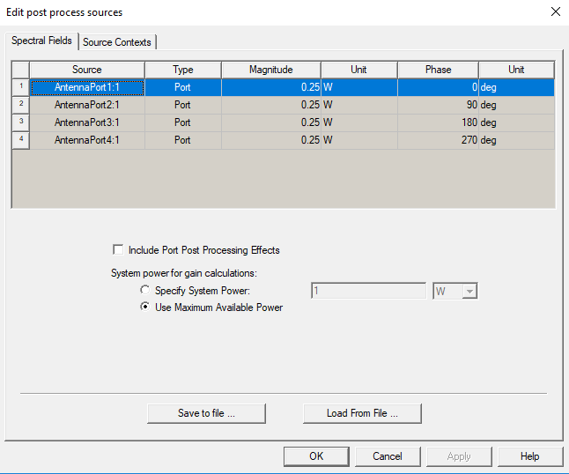

NOTE: In some older models mislabeled antenna 3 and 4 in the original model. In this case the easy solution is to switch port 3 and port 4’s phase angles. For the final model I have corrected this to make it simpler to read!

1. Assign a medium in which the signal will transmit (in our case and in most cases vacuum is a safe assumption)

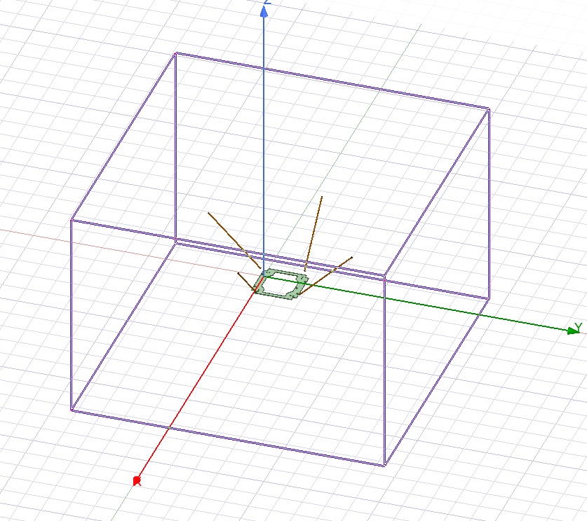

1. Define a solution of frequencies you want to solve over

In our case 430-440 MHz, results will be shown over 435MHz for consistency sake.

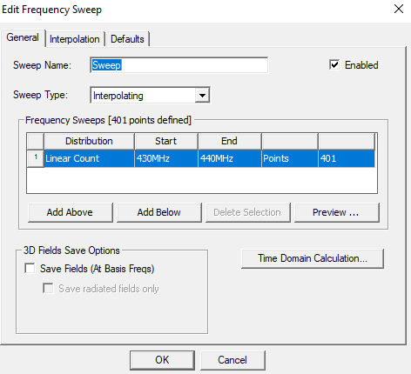

1. Run the analysis
2. Plot the LHCP results

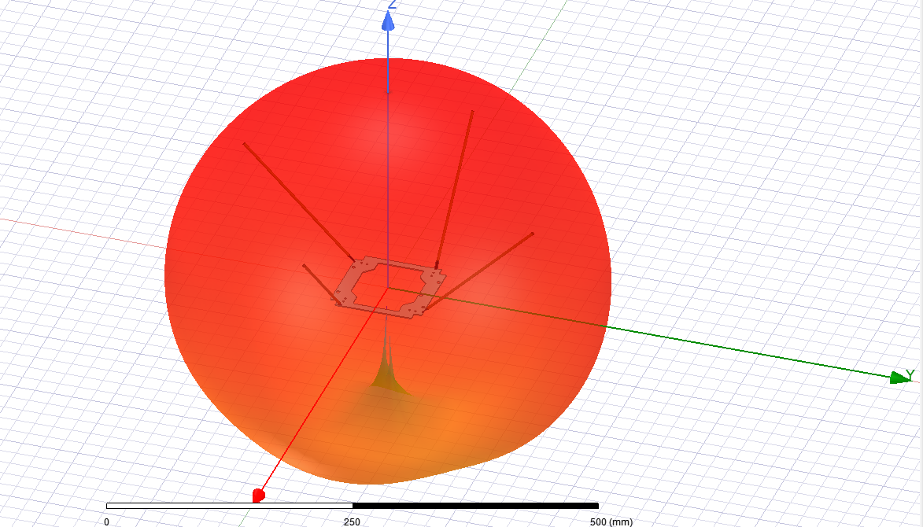

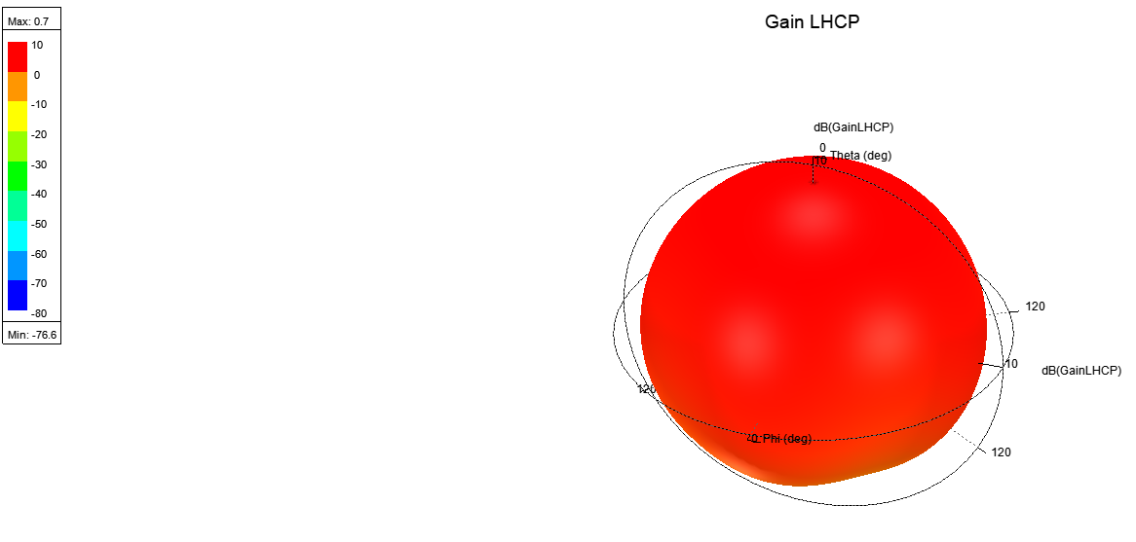

1. Plot the RHCP results

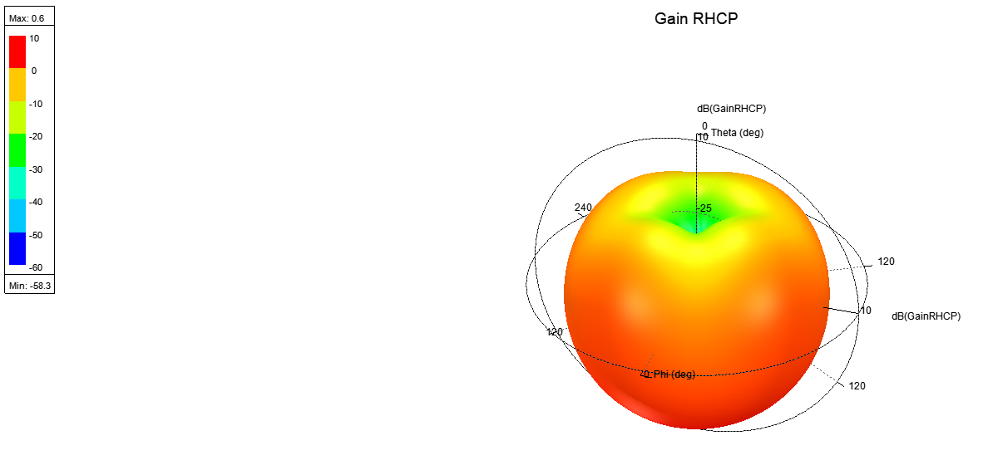

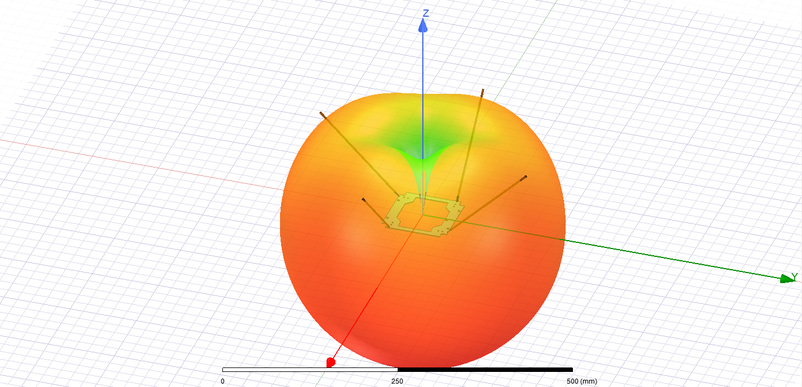

1. Plot the total gain of the antenna

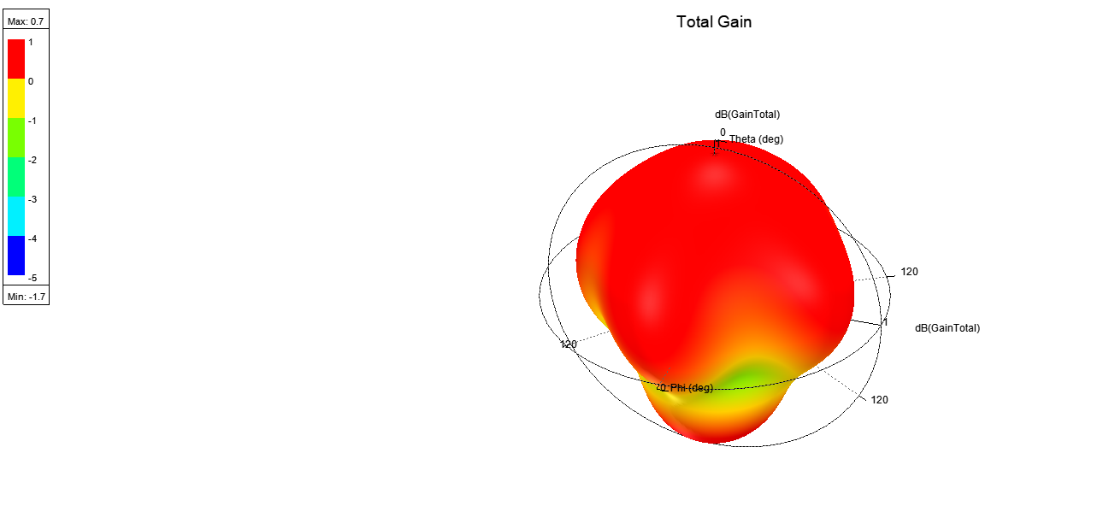

Note that the difference between max and min is less than 3dB therefore it has no null vector.

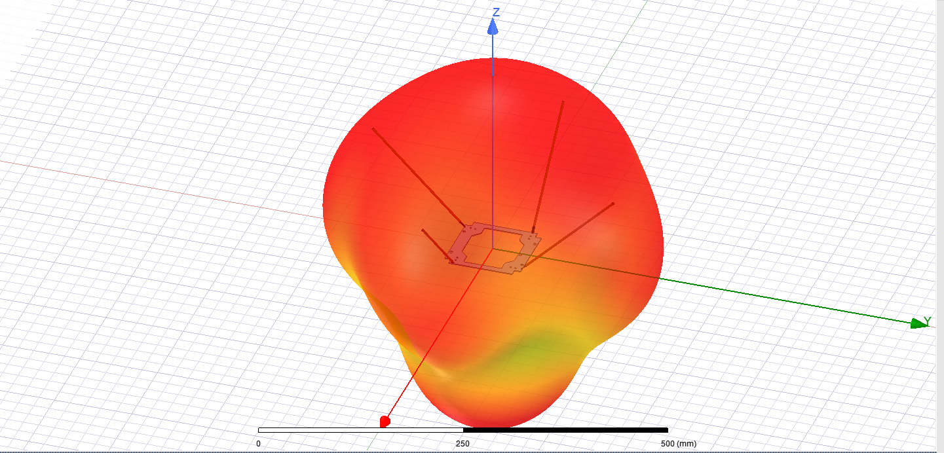

Next step would be to add the cubesat structure. Note that the difference in RHCP and LHCP should be smoothened out a bit by adding the cubesat which is acting as a physical amplifier in the RHCP direction.

1. Import the STEP file for the cubesat structure

Note it is very common in literature (and Gomspace themselves in there CST model) to only use the frame of the cubesat as it will have the largest effect on the radiation pattern.

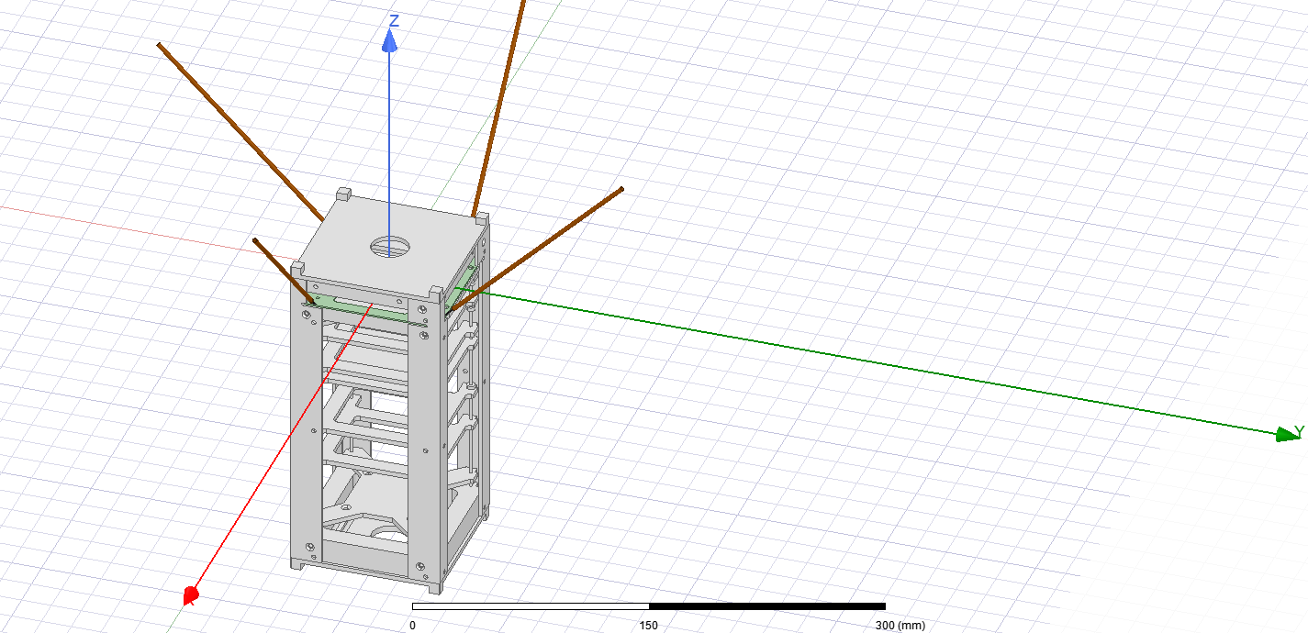

1. Plot LHCP

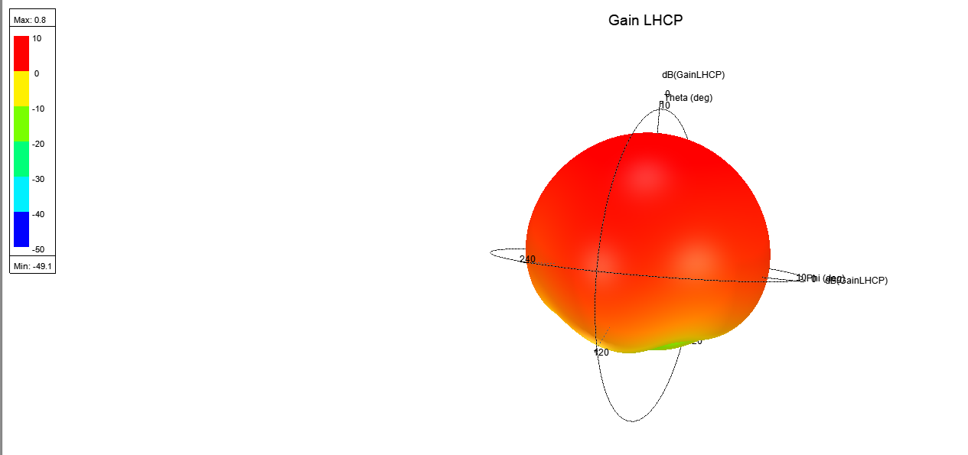

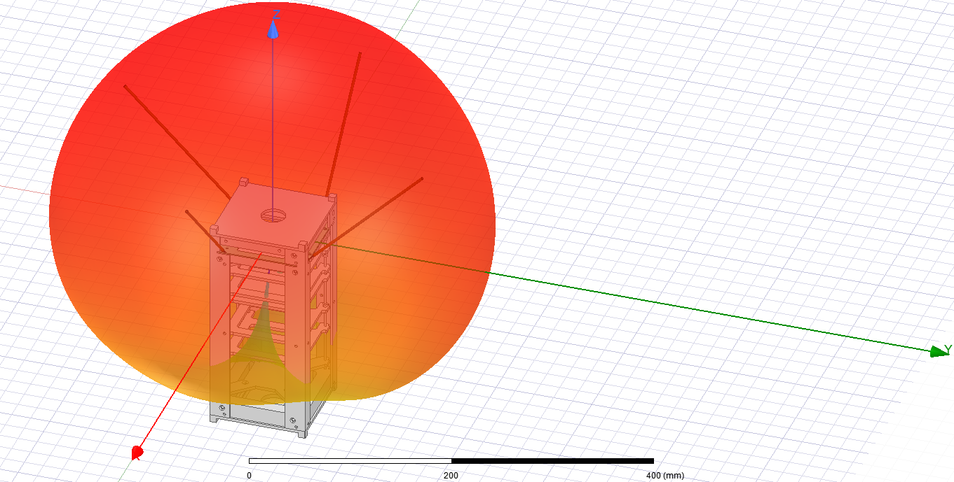

1. Plot RHCP

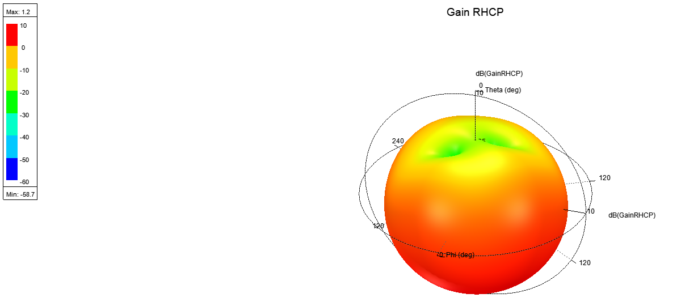

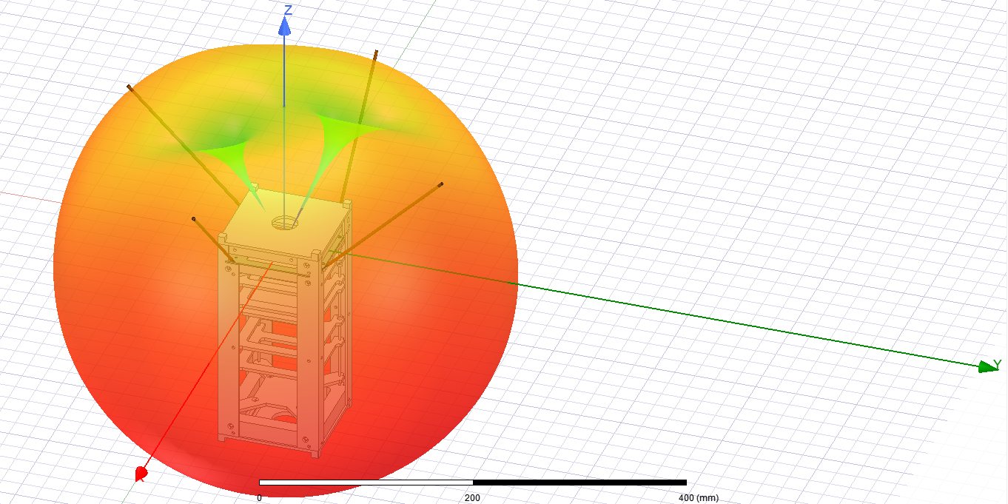

1. Plot Total Gain

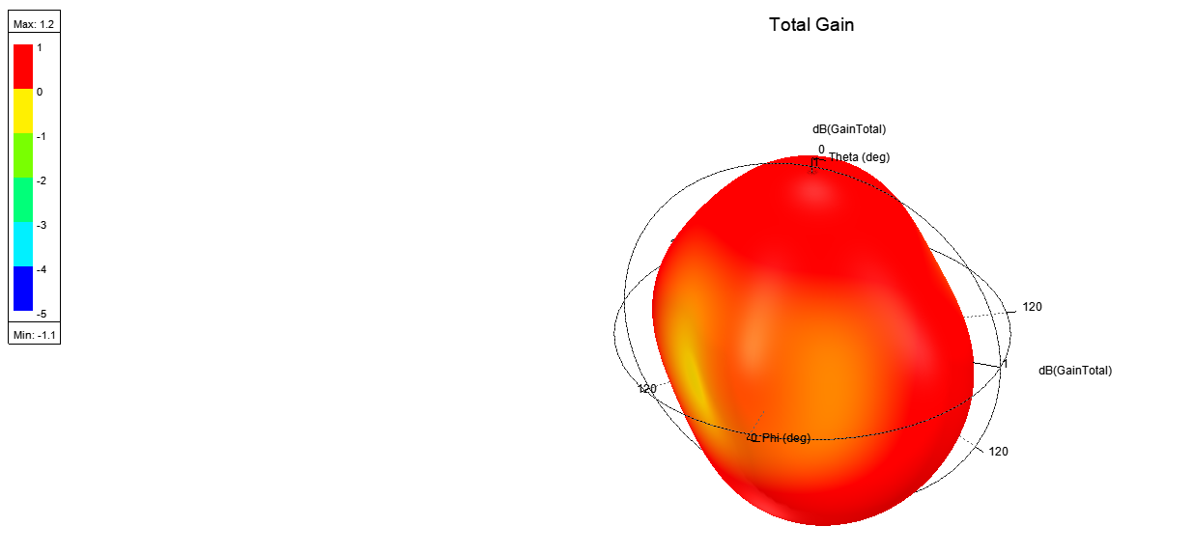

Note the difference in max and min gain is still less than 3dB therefore there is no null vector

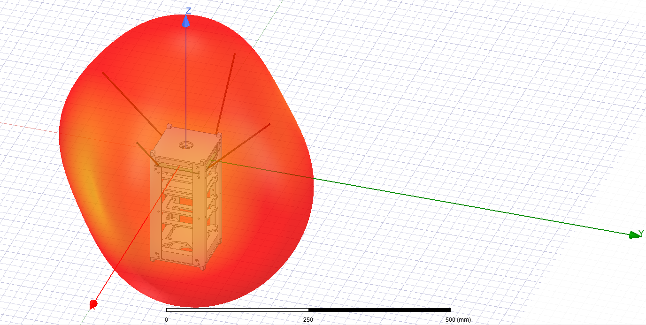

1. Plot Elevation Plane

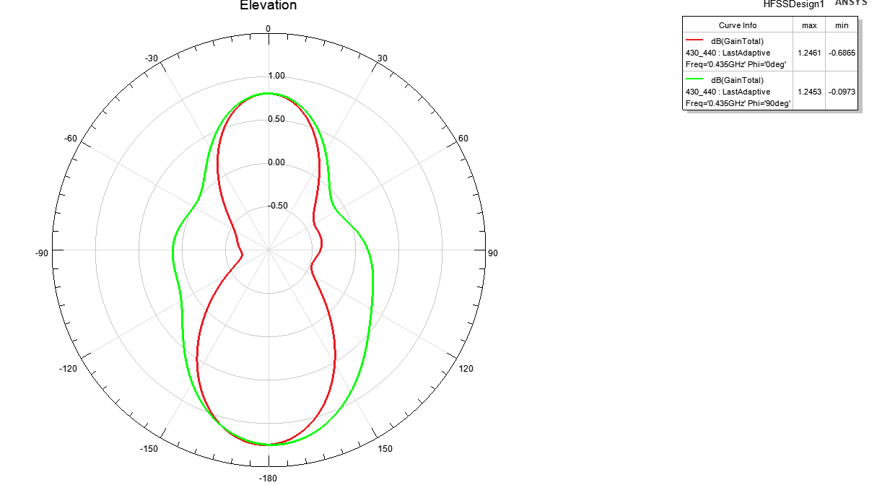

1. Plot Azumith Plane

